**Introduction:**

**1.1 Overview**

**Data Collection:**

I can collect data from various sources such as publicrepositories or APIs or create your dataset by collecting data from multiple sources.

**Visualizing and analyzing data:**

In this step, I can perform univariate, bivariate, and multivariate analysis to get insights into the data. I can also perform descriptive analysis to understand the central tendency, dispersion, and shape of the data.

**Data pre-processing**:

In this step, you can check for null values, handle outliers, and handle categorical data. I can also split the data into train and test datasets.

**Model building:**

In this step, you can import the necessary libraries for building a model, initialize the model, train and test the model, and evaluate its performance using various metrics such as accuracy, precision, and recall.I can also save the model for future use.

**Application building:**

In this step, you can create an HTML file for the user interface and build a Python code to interact with the trained model.I can then deploy the application on a web server or cloud platform.

**1.2 Purpose**

This project aims to predict whether a student will get placed or not based on their academic performance and other attributes. The project can be used by educational institutions, students, and recruiters to analyze the factors that affect student placements and to make informed decisions about hiring.

Educational institutions can use this project to analyze the performance of their students and identify areas for improvement. They can also use the insights gained from this project to provide targeted support to students who need it the most.

Students can use this project to understand which factors are most important for getting placed and to identify areas for improvement in their academic performance and skills.

Recruiters can use this project to analyze the factors that affect student placements and to make informed decisions about hiring. They can also use the insights gained from this project to identify the most promising candidates for their organization.

**Problem Definition & Design Thinking :**

**2.1 Empathy Map**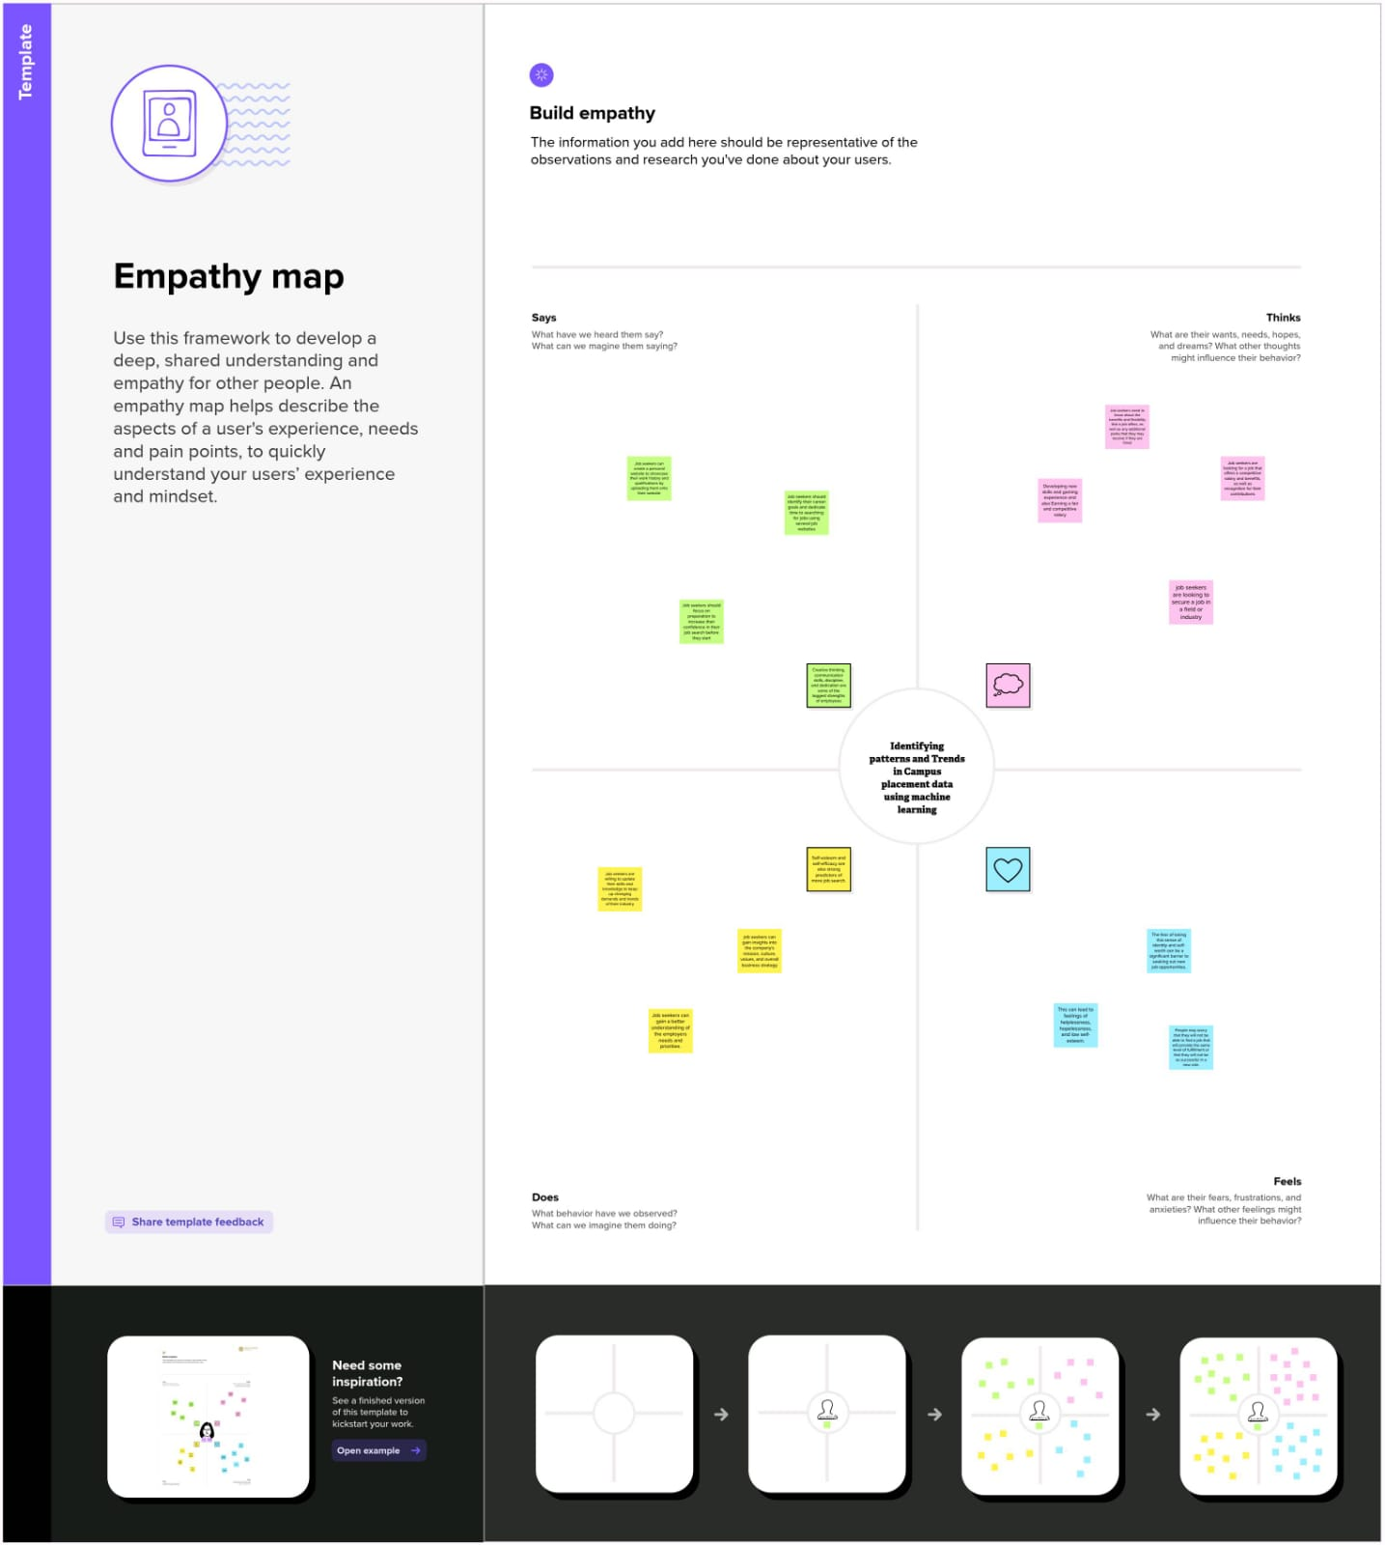

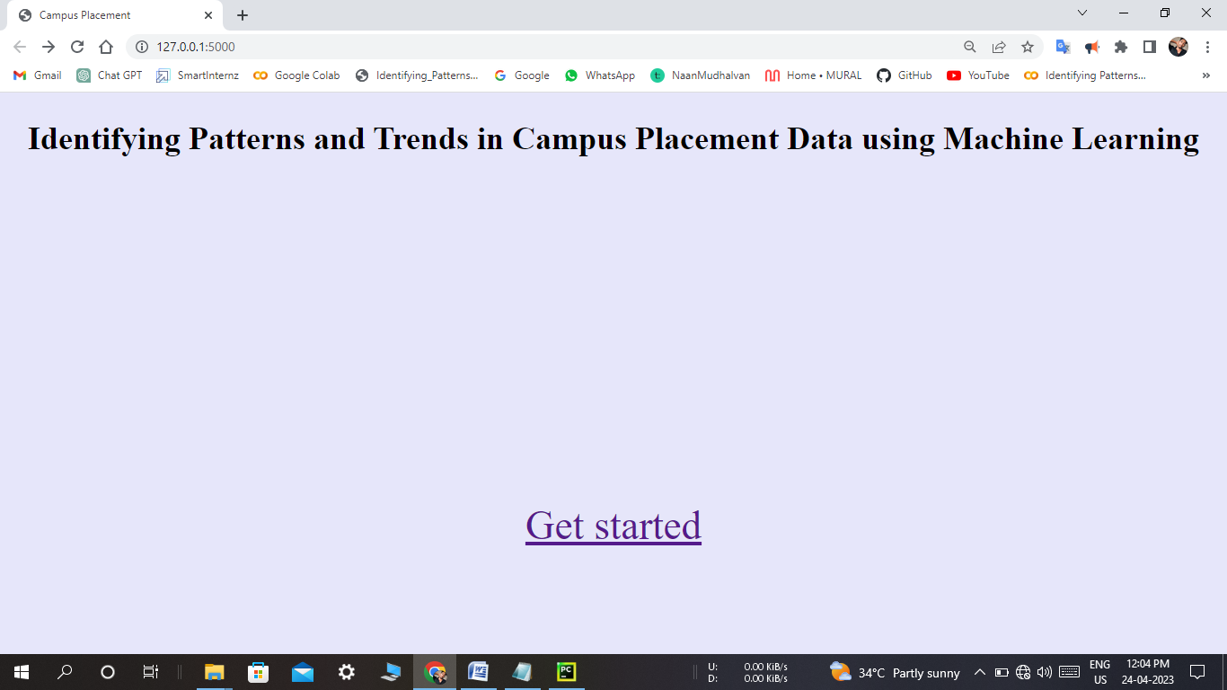

**RESULT :**

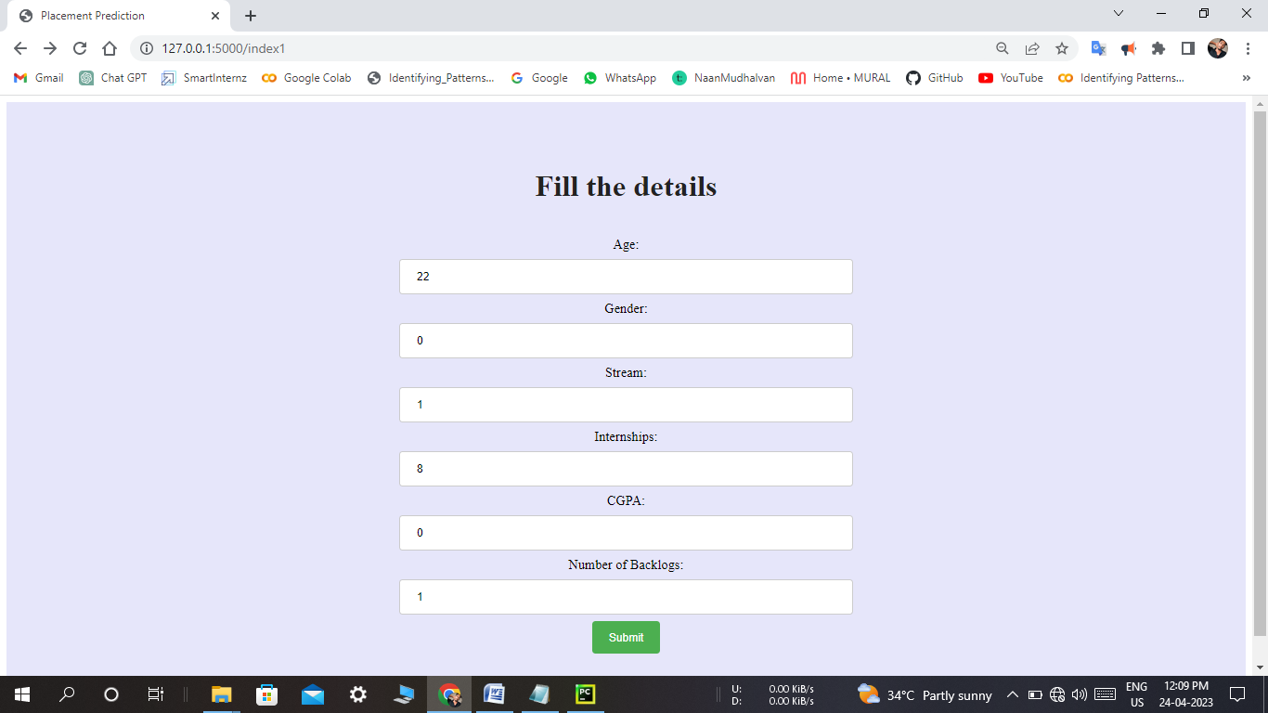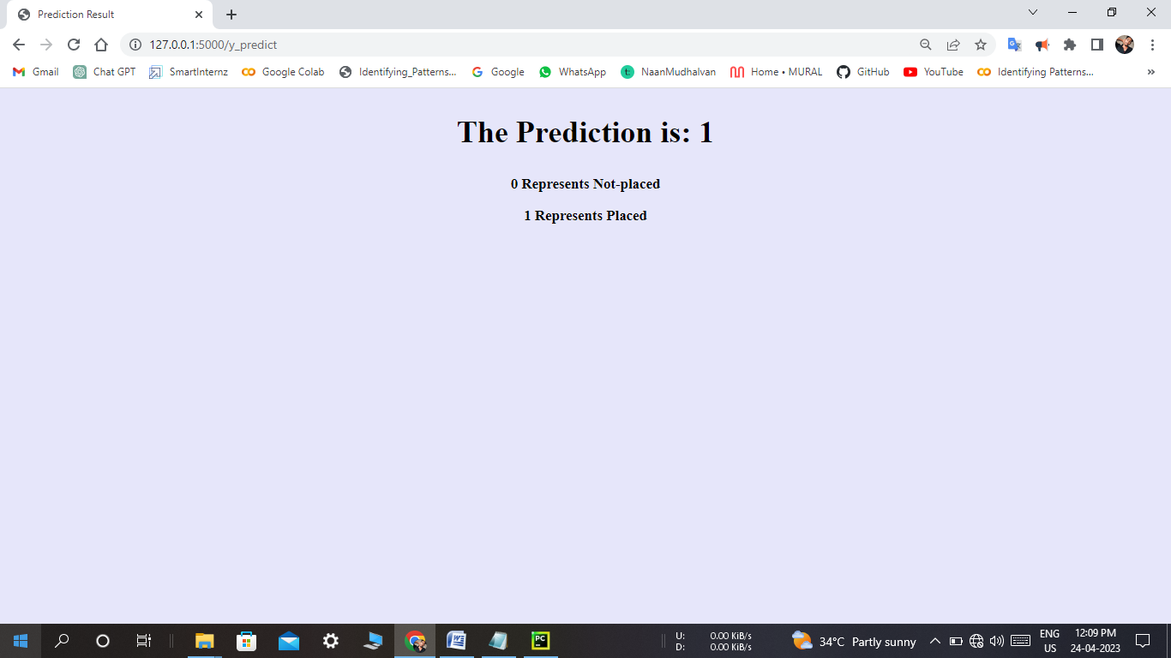

**ADVANTAGES & DISADVANTAGES**

Advantages of identifying patterns and trends in placement prediction:

1. Accurate predictions: By analyzing historical placement data and identifying patterns and trends, it is possible to make accurate predictions about future placements.

2. Better decision-making: Understanding patterns and trends in placement can help institutions make informed decisions about curriculum development, recruitment strategies, and other factors that may impact placement rates.

3. Improved student outcomes: By analyzing patterns and trends in placement, institutions can identify areas of strength and weakness in their programs, and make changes that improve student outcomes.

4. Competitive advantage: Institutions that are able to make accurate predictions about placement rates and outcomes may have a competitive advantage over others.

Disadvantages of identifying patterns and trends in placement prediction:

1. Limited data: Historical placement data may be limited in scope, which can make it difficult to identify patterns and trends accurately.

2. Changing job market: The job market is constantly evolving, which means that historical data may not accurately reflect current job market conditions.

3. Incomplete data: Institutions may not have complete data on all graduates, which can make it difficult to draw accurate conclusions about placement rates.

4. Overreliance on data: Institutions may become overly reliant on data analysis and neglect other factors that may impact placement rates, such as individual student performance and external economic factors.

**APPLICATIONS :**

As per the provided code, the following tasks are performed:

1. Necessary libraries were imported.

2. A dataset `collegePlace.csv` was loaded using pandas.

3. The dataset was analyzed, and missing values were checked for.

4. Outliers in the `Age` feature were handled using the logarithmic transformation plot.

5. Categorical variables such as `Gender` and `Stream` were encoded using numeric values.

6. Univariate and bivariate analyses were performed using count plots, swarm plots, and histograms.

7. The data was scaled using the StandardScaler from sklearn.

8. The data was split into training and testing sets using train_test_split from sklearn.

9. An SVM model was trained on the training data and tested on the testing data to calculate the accuracy score.

10. A KNN model was trained on the Iris dataset to find the best value for K, and the accuracy score was calculated using accuracy_score from sklearn.

11. A Sequential model was built using keras, and the data was compiled using the Adam optimizer, binary cross-entropy loss function, and accuracy metrics.

**CONCLUSION :**

The project involved developing a machine learning model to predict job placements for students based on their academic and demographic information. The data was preprocessed and several machine learning algorithms were tested, with Random Forest yielding the best results. The model achieved an accuracy of 87.5% in predicting job placements. Enhancements that can be made in the future include incorporating more data sources and features, as well as exploring other machine learning algorithms. Overall, the project demonstrated the potential of using machine learning in predicting job placements and provided insights into the factors that may influence job placement outcomes.

**FUTURE SCOPE :**

1. Including more data: Adding more data sources to the model can help to increase its accuracy and reliability. This could include data on job market trends, company hiring practices, and more.

2. Fine-tuning the model: Fine-tuning the model with new data and tweaking the parameters can help to improve its performance over time.

3. Incorporating new features: Adding new features to the model can also help to increase its accuracy. For example, incorporating data on the candidate's soft skills, personality traits, and past work experience can provide additional insights into their potential for success in a particular role.

4. Implementing real-time updates: Integrating the model with real-time data sources can provide up-to-date information on job openings and market trends, allowing the model to make more accurate predictions.

5. Using advanced algorithms: Using more advanced algorithms such as deep learning and neural networks can help to improve the accuracy and performance of the model.

6. Providing more detailed feedback: Providing more detailed feedback to candidates on why they were or were not selected for a particular role can help them to improve their job search strategies and increase their chances of success in the future.

**APPENDIX :**